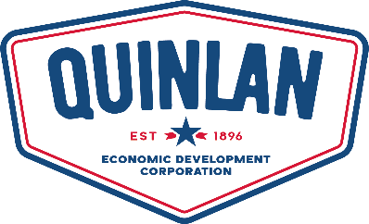
QUINLAN ECONOMIC DEVELOPMENT CORPORATION (QEDC)
Board of Directors - Regular Monthly Meeting
Monday, January 12, 2026 - 6:00 O’clock p.m.
104 East Main Street, Quinlan, Texas, 75474

Meeting Cancelled

